ORTHOPAEDIC INSTRUMENTS
Instruments for Ender Nails
Bone Awl
Intended Use
The bone awl is a hand-held puncturing instrument used in veterinary orthopaedic surgery to create the cortical entry point for Ender nail insertion into the medullary canal of long bones in dogs and cats. It penetrates the cortex at the nail entry site during intramedullary fracture fixation procedures. | 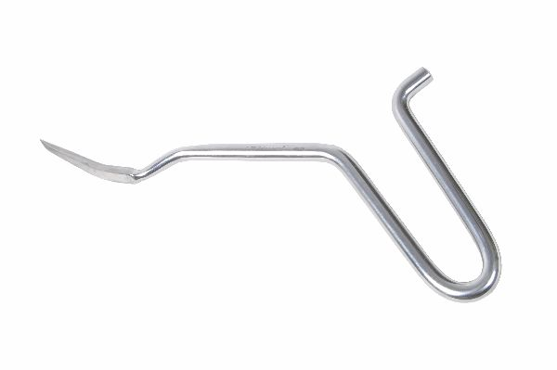
Function
The instrument has a hardened, sharply pointed tip on a rigid steel shaft attached to a T-bar or pistol-grip handle. Firm hand pressure combined with a rotating action drives the tip through the cortical shell at the metaphyseal entry site, creating a pilot hole that guides the first Ender nail into the medullary canal without requiring a power drill.
Advantages
Controlled Cortical Entry Without Power Equipment: Hand-driven awl insertion avoids the risk of cortical crack propagation from power drilling at the thin metaphyseal entry site — particularly important in the distal femur and proximal tibia of immature or small-breed dogs.
Precise Entry Point Placement: The sharp tip allows the surgeon to select and commit to the exact cortical entry position before penetration begins, enabling accurate nail trajectory planning to achieve the desired medullary canal engagement.
FAQ
Q: What bone is the bone awl used on for Ender nail insertion?
A: The awl is most commonly used at the distal femoral or proximal tibial metaphysis to create the cortical entry portal for retrograde or antegrade Ender nail insertion in canine long-bone fractures.
Q: Can the bone awl be used for intramedullary pin insertion?
A: Yes. The bone awl is also used to create entry portals for Rush pins and other smooth intramedullary pins used in small-animal fracture fixation beyond the dedicated Ender nail technique.

ORTHOPAEDIC INSTRUMENTS
Instruments for Ender Nails
Ender Nail Bender - Roller Type
Intended Use
The roller-type Ender nail bender is a pre-contouring instrument used in veterinary orthopaedic surgery to apply a controlled, smooth curve to Ender nails before intramedullary insertion into the long bones of dogs and cats. Correct nail curvature is essential for achieving three-point endosteal fixation in the medullary canal. | 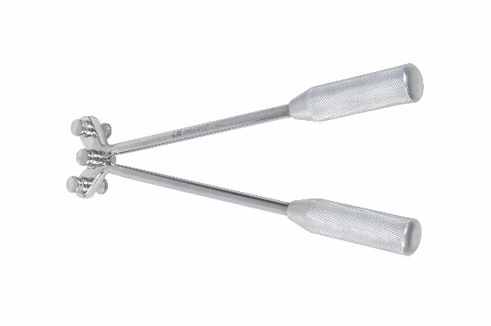
Function
The instrument has two fixed outer rollers and one central pressure roller. The nail is placed across the outer rollers and the central roller is advanced by a threaded handle mechanism, bending the nail over its span. The roller configuration distributes the bending force across a length of nail rather than at a single point, producing a smooth, crack-free curved contour without stress notching.
Advantages
Smooth Distributed Bend Without Stress Risers: The three-roller design bends the nail over a radius rather than at a focal point, preventing surface stress notching and micro-crack formation that would weaken the nail at the bend site under cyclic loading during weight-bearing.
Reproducible Curvature for Three-Point Fixation: The threaded central roller allows the bend radius to be set to a reproducible value for each nail, ensuring all nails in a bundled fixation construct have matching curvature for symmetric three-point endosteal contact.
FAQ
Q: How much curvature should be applied to Ender nails?
A: Ender nails are typically bent to a radius of curvature matching approximately the internal diameter of the medullary canal at its narrowest isthmus point to maximise three-point endosteal contact and rotational stability.
Q: Can the roller bender be used for Rush pins?
A: Yes. The roller bender is compatible with the wire gauges used for Rush pins (1.6–3.0 mm), allowing precise curvature application for Rush pin intramedullary fixation in small animals.

ORTHOPAEDIC INSTRUMENTS
Instruments for Ender Nails
Ender Nail Impactor
Intended Use
The Ender nail impactor is a driving instrument used in veterinary orthopaedic surgery to advance Ender nails along the medullary canal by controlled mallet impaction during intramedullary fracture fixation in dogs and cats. It transfers driving force from the mallet to the nail end without bending or deforming the nail. | 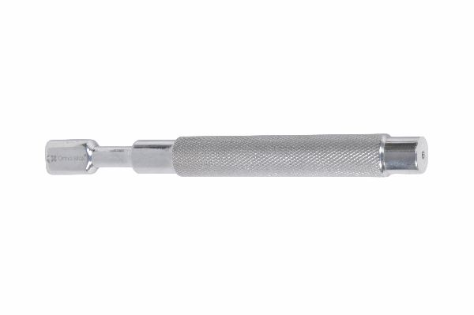
Function
The impactor has a proximal striking face that accepts mallet blows and a distal female socket or slot that engages the nail end. The solid steel body transmits impact energy axially from the striking face to the nail without lateral force components that would deflect the nail from its medullary path. A handle allows the surgeon to control nail trajectory during impaction.
Advantages
Axial Force Transmission Without Nail Deflection: Direct socket engagement with the nail end ensures impact force is transmitted along the nail axis, preventing the lateral bending forces that occur when a mallet strikes the nail directly — forces that can divert the nail tip from the medullary canal.
Protects Nail End From Mallet Damage: The impactor face absorbs repeated mallet blows without transmitting damaging stress concentrations to the thin nail end, preserving the nail's mechanical integrity and smooth surface that are critical for future nail extraction.
FAQ
Q: What mallet is used with the Ender nail impactor?
A: A standard orthopaedic mallet weighing 230–450 g is used with the Ender nail impactor; the weight is selected based on the nail diameter and medullary canal resistance encountered during insertion.
Q: Can the impactor be used for nail extraction as well as insertion?
A: No. A dedicated extractor head and slotted extraction hammer are used for nail removal; the impactor is not designed to withstand the tensile extraction forces and would be damaged by reverse impaction attempts.

ORTHOPAEDIC INSTRUMENTS
Instruments for Ender Nails
Intramedullary Nail Extractor Head
Intended Use
The intramedullary nail extractor head is a specialised coupling component used in veterinary orthopaedic surgery to grip the exposed end of an Ender nail or intramedullary pin for controlled extraction from the medullary canal in dogs and cats after fracture union, enabling implant removal without damaging the surrounding bone. | 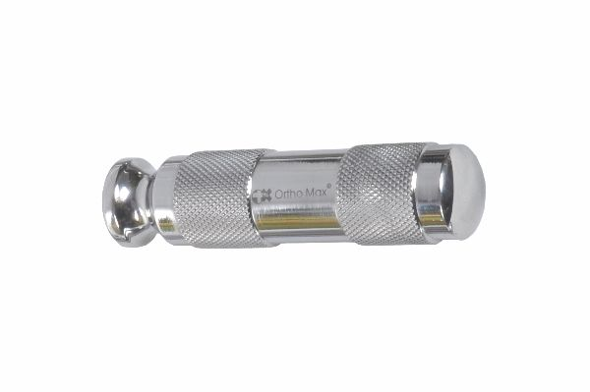
Function
The extractor head incorporates a threaded or spring-loaded jaw that engages the nail end or a dedicated extraction hole in the nail tip. It connects to the extraction rod which passes through the slotted hammer. Reverse-impaction blows to the slotted hammer slide the hammer toward the proximal stop on the rod, transmitting tensile force via the extractor head to withdraw the nail from the bone.
Advantages
Secure Nail Engagement for Controlled Extraction: Positive mechanical engagement with the nail end or extraction eye ensures all reverse-impaction force is transmitted directly to the nail, preventing slippage that would damage the periosteal surface at the nail entry site.
Compatible with Multiple Nail Diameters: Extractor heads are available in multiple sizes matching standard Ender nail and Rush pin diameters, allowing the same slotted hammer and extraction rod to be used for all standard intramedullary implant removal procedures.
FAQ
Q: When is intramedullary nail removal indicated in veterinary patients?
A: Nail removal is indicated after radiographic confirmation of fracture union (typically 8–16 weeks), or earlier if implant migration, infection or soft-tissue irritation from nail ends is identified.
Q: Can Ender nails be removed without a dedicated extractor?
A: In some cases, accessible nail ends can be grasped with heavy pliers, but the purpose-designed extractor head and slotted hammer provide safer, more controlled extraction with significantly less periosteal trauma.

ORTHOPAEDIC INSTRUMENTS
Instruments for Ender Nails
Intramedullary Nail Extractor Rod
Intended Use
The intramedullary nail extractor rod is the central connecting element of the Ender nail extraction assembly used in veterinary orthopaedic surgery. It links the extractor head to the slotted hammer, transmitting the reverse-impaction force needed to withdraw Ender nails and intramedullary pins from long bones in dogs and cats after fracture union. | 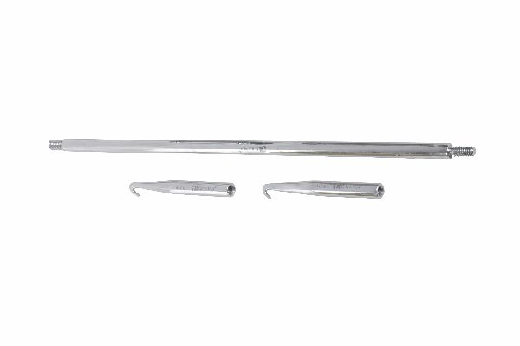
Function
The solid steel rod has a distal threaded end that accepts the extractor head and a proximal collar that serves as the stop against which the slotted hammer slides. The rod passes through the central channel of the slotted hammer. When the hammer is swung upward and impacts the proximal collar, the momentum is transmitted through the rod and extractor head as a tensile extraction pulse on the nail.
Advantages
Solid Steel Construction for High Tensile Load Transmission: The solid rod cross-section ensures high tensile load transmission without elastic deflection during reverse-impaction extraction, even when fibrous tissue ingrowth has significantly increased the force required to disengage the nail from the medullary canal.
Compatible Length for Long-Bone Nail Extraction: Rod lengths are designed to project sufficiently beyond the skin surface after extractor head engagement to allow the slotted hammer to generate adequate momentum during the extraction stroke for all standard long-bone nail lengths.
FAQ
Q: What are the components of the complete Ender nail extraction set?
A: The complete set comprises the extractor head (sized to the nail diameter), the extractor rod (connecting head to hammer), and the slotted hammer that generates the reverse-impaction extraction force.
Q: Can the extractor rod be used with intramedullary nails other than Ender nails?
A: Yes. The extractor rod and slotted hammer work with any extractor head compatible with the target nail diameter, covering Rush pins, Steinmann pins and custom intramedullary implants in veterinary use.

ORTHOPAEDIC INSTRUMENTS
Instruments for Ender Nails
Intramedullary Nail Extractor Slotted Hammer
Intended Use
The intramedullary nail extractor slotted hammer is the impact-generating component of the Ender nail extraction system used in veterinary orthopaedic surgery. It generates the reverse-impaction force required to disengage and withdraw Ender nails and intramedullary pins from long bones in dogs and cats after fracture healing. | 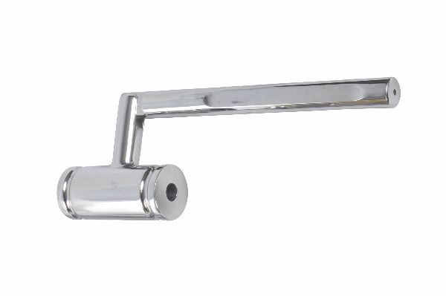
Function
The hammer body has a central longitudinal slot through which the extraction rod passes freely. The surgeon slides the hammer mass along the rod and allows it to impact the proximal rod collar in a sharp reverse-direction stroke. The momentum of the hammer mass at impact is transmitted through the collar and rod to the extractor head as a sudden tensile extraction force on the nail.
Advantages
High-Momentum Impact for Adherent Nail Extraction: The heavy hammer mass generates sufficient momentum per stroke to disengage nails secured by fibrous tissue ingrowth or cortical bone overgrowth at the nail tip — conditions that make manual traction or plier extraction impossible.
Controlled Extraction Without Bone Fracture Risk: The repeated low-amplitude impaction strokes of the slotted hammer generate progressive extraction rather than a single large force, reducing the risk of cortical fracture at the nail entry site that can occur with sudden, uncontrolled extraction attempts.
FAQ
Q: How many impaction strokes are typically needed to extract an Ender nail?
A: An uncomplicated extraction after complete fracture union typically requires 10–30 strokes; firmly adherent nails with fibrous ingrowth may require 50+ strokes with progressively increasing hammer velocity.
Q: What weight is the standard Ender nail extractor slotted hammer?
A: Standard veterinary slotted extraction hammers weigh 300–500 g, providing sufficient momentum for small to large-breed dog nail extraction without requiring excessive surgical assistant effort.

ORTHOPAEDIC INSTRUMENTS
Instruments for Ender Nails
Setting Device
Intended Use
The Ender nail setting device is a positioning instrument used in veterinary orthopaedic surgery to correctly orient multiple Ender nails within the medullary canal of long bones in dogs and cats during bundled intramedullary fixation. It rotates each nail to the desired final orientation after insertion to maximise three-point endosteal contact. | 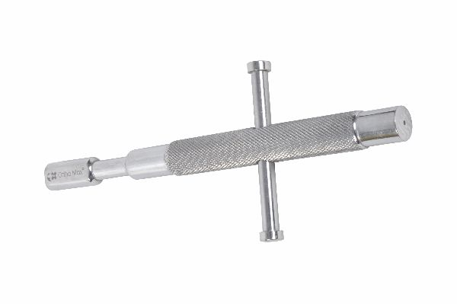
Function
The device engages the bent tip or eye of the Ender nail through the entry portal and allows the surgeon to rotate the nail around the medullary canal axis. Rotating the nail repositions the three-point contact arc of its curvature within the canal, enabling the surgeon to fan multiple nails evenly around the medullary circumference to maximise bundled nail resistance to bending and rotation.
Advantages
Optimal Multi-Nail Spatial Distribution: The setting device enables precise fan-like distribution of multiple Ender nails around the medullary canal, maximising the effective moment of inertia of the nail bundle and substantially increasing bending stiffness compared with uncontrolled nail clustering.
Controlled Rotation Without Nail Withdrawal: The tool rotates the nail within the canal without requiring partial withdrawal or re-insertion, maintaining the established nail trajectory and reducing the risk of cortical penetration during intramedullary repositioning.
FAQ
Q: How many Ender nails are typically used in canine fracture fixation?
A: Two to four Ender nails are typically used per fracture, distributed evenly around the medullary canal using the setting device to create a bundle with adequate bending and rotational stiffness.
Q: Is the setting device used for Rush pin fixation as well?
A: Rush pins have a pre-bent hook tip that self-positions in the medullary canal; a setting device is less commonly needed, though it can assist in repositioning pins that have not engaged the far cortex correctly.

ORTHOPAEDIC INSTRUMENTS
Instruments for Ender Nails
Slotted Bender in Pair
Intended Use
The slotted bender pair is a two-piece manual bending instrument set used in veterinary orthopaedic surgery to apply a precise single-point bend to Ender nails and intramedullary pins during fracture fixation in dogs and cats. The pair provides controlled angle and radius of bend when a roller bender is unavailable or when only a localised bend is required. | 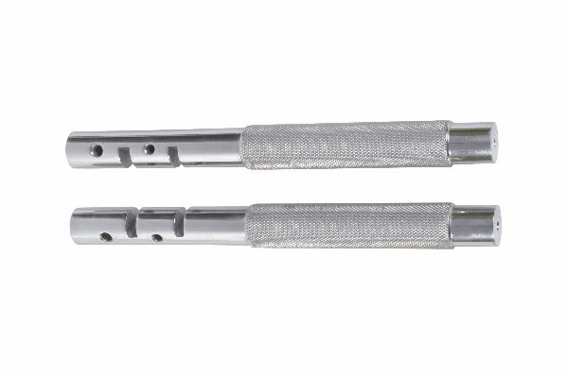
Function
Each bender in the pair is a stainless steel bar with a longitudinal slot that accepts the nail shaft. One bender is held fixed near the bend point while the second is slid along the nail and used as a lever to apply a bending force at the gap between the two benders. The gap width between the benders determines the bend radius — wider gap gives a gentler curve, narrower gap a tighter bend.
Advantages
Point-Specific Bend Placement: The dual-bender technique allows the bend to be applied at a precisely chosen point along the nail length, enabling the surgeon to place the apex of curvature at the exact position needed for optimal medullary contact in a specific patient's bone anatomy.
No Power Equipment Required: Manual slotted benders function without a bench vice, power tools or specialised equipment, making them the preferred bending method in field or ambulatory surgical settings where power bending equipment is unavailable.
FAQ
Q: How does the slotted bender pair differ from the roller-type bender?
A: The roller bender produces a smooth distributed curve over the full nail length; the slotted bender pair creates a single focal bend at one point. Roller bending is preferred for achieving the smooth three-point canal contact curvature required for Ender nail fixation.
Q: Can slotted benders be used to straighten bent nails for reuse?
A: Straightening previously bent nails is not recommended as it creates fatigue damage at the original bend site; all deformed nails should be replaced with new implants rather than re-bent for reuse.

